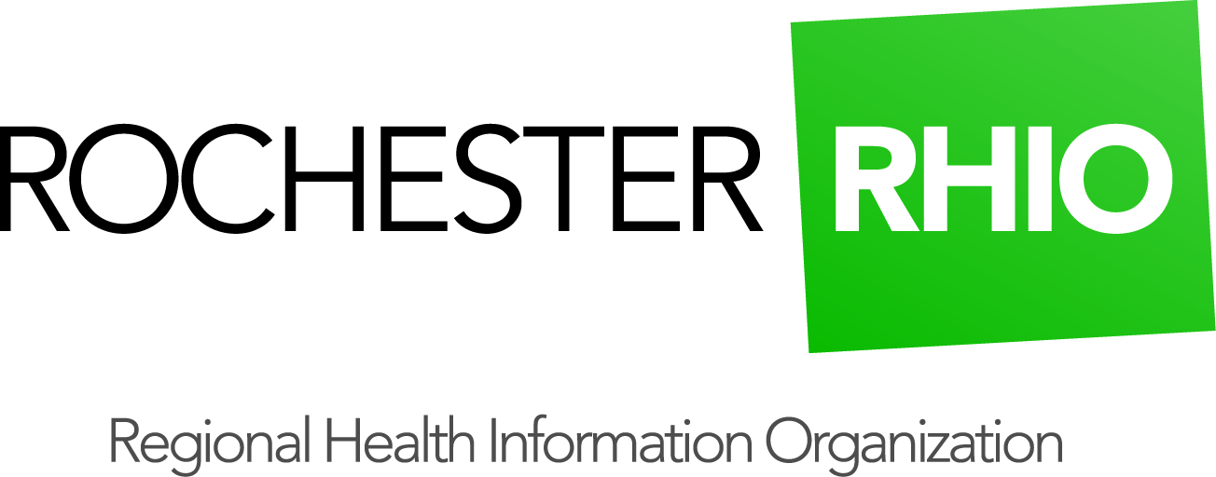
Image Enabled Results Delivery (IERD)
Rochester RHIO now provides access to imaging studies directly through reports delivered to practice EHRs.
- Available to practices receiving MyResults Delivered though the Rochester RHIO
- Simple to use, just open a report, click a link to the image and enter a PIN.
- Embedded clinical viewer, no separate login required.
- Check off a Meaningful Use 2 menu set requirement

Frequently Asked Questions

1. How long does it take for the image to load? In general, images are immediately available within the first 30 days. After 30 days, images can be retrieved at any time, however there may be up to a 5 minute delay to view the image.

2. How long is the image available through the RHIO? The RHIO does not archive images, so users continue to have access to images through the RHIO. Once an image is 30 days old, it may take up to 5 minutes for the image to load.

3. Does IERD work with my EHR?
How you use IERD may vary by your EHR. The following EHRs have implemented IERD:
- eClinical Works
- Medent
- NextGen
- STI
(Additional vendors can be added as practices request this service.)

4. What does IERD cost?
The RHIO does not charge an ongoing fee for IERD. There is a set-up fee for each practice of $200.00 per physician (MD, DO, DC, DPM, OD). All RHIO users in a practice will have IERD access, including non-physician RHIO users. There is also a $200.00 fee to add a new physician to a practice.

5. Is training available?
Rochester RHIO Deployment Staff will schedule a brief training for each practice adopting IERD services.

6. Who handles support questions?
Call the Rochester RHIO support line (1-877-865-7446 or email info@grrhio.org) with IERD questions or issues. The RHIO team will be able to identify next steps for solving issues.

7. What happens if I need a report resent?
The image link is not included when a report is resent. In order to view an image associated with a report, please go to RHIO’s query portal.

6.18.15

